SOLUTION DOCUMENT

Real-Time Fraud Detection System

(Architecture + Data Flow + ML + Rules + UI + API + Components)

1. Overview
This solution implements a real-time fraud detection platform combining:
- Supervised ML model (LightGBM)
- Unsupervised anomaly model (Isolation Forest)
- Deterministic rule engine
- Behavioral scoring
- Geo-risk scoring
- Device & velocity rules
- Time-of-day and pattern risk
- User interface (Streamlit)
- API interface (FastAPI)
The platform assigns a fraud risk score (0–100) and a final label:
LOW / MEDIUM / HIGH / CRITICAL
The system is fully explainable, auditable, and suitable for production.

2. Architecture Diagram

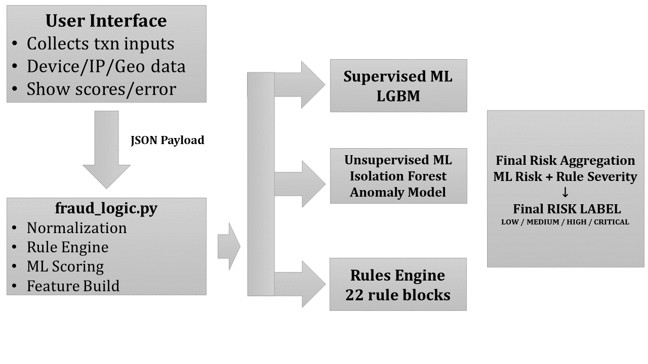

3. Data Flow
- User enters transaction details
- Payload is built with:
  - Amount, location, currency
  - Device/browser
  - Time-of-day
  - Transaction city/country
  - Home city/country
  - Telemetry (velocity, averages)
- ip_country is automatically derived from txn_country
- ML model receives 8 features:
  - Amount
  - TransactionType
  - Location (txn_city)
  - DeviceID
  - Channel
  - hour
  - day_of_week
  - month
- Isolation Forest produces anomaly magnitude
- Rule engine evaluates:
  - 22 deterministic rules
  - Geo mismatch
  - Time of day
  - Velocity
  - Beneficiary risk
  - Card/ATM risk
- ML + Rules fused into final severity.

4. Machine Learning Logic

4.1 Supervised Model (LightGBM)
Predicts probability of fraud:
- Output range: 0.0 → 0.02 generally
- Converted to Fraud Risk Score (0–100)

4.2 Unsupervised Model (Isolation Forest)
Measures unusualness of the transaction:
- Raw score inverted
- Normalized to Anomaly Score (0–100)

4.3 Risk Labeling
If fraud_prob >= 0.0173 → CRITICAL
If fraud_prob >= 0.00023 → HIGH
If fraud_prob >= 0.00005 → MEDIUM
Else LOW

4.4 Score Normalization
Fraud Score (0–100) = (fraud_prob / 0.02) * 100
Anomaly Score (0–100) = (anomaly_score / 0.10) * 100
Ensures business interpretability.

5. Rule Engine Overview (22 rules)
Categories:
- Extreme Amount Rules
- Geo-Risk Rules
- Device Risk
- Impossible Travel
- Velocity Rules
- Card Behavior
- ATM behavior
- Beneficiary Risk
- Daily & Monthly Pattern Risk
- Time-of-Day Rules
Rules produce severity levels:
- LOW
- MEDIUM
- HIGH
- CRITICAL
Highest severity becomes the rule score.

6. Final Risk
Final_Risk = MAX( ML_Risk_Label , Rules_Severity )
Example:
- ML = MEDIUM
- Rules = HIGH
→ Final Risk = HIGH

7. Response Time
Total end-to-end scoring time measured:
start_time = time.perf_counter()
end_time = time.perf_counter()
response_time = end_time - start_time
Displayed to the user.

8. API Layer (FastAPI)
The API receives the same payload as UI.
Response includes:
- FraudProbabilityRaw
- AnomalyScoreRaw
- FraudRiskScore (0–100)
- AnomalyRiskScore (0–100)
- ML Risk Label
- Rule triggers
- Final Risk

9. Deliverables Provided
- Full source code
- Optimized app.py
- fraud_logic.py
- FastAPI app
- Normalized scoring
- Response time integration
- Documentation
- KT-ready explanation
- Example transactions dataset

